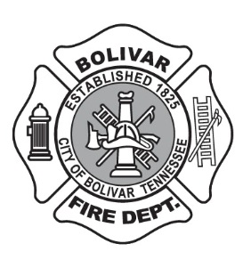
CITY OF BOLIVAR FIRE DEPARTMENT
VOLUNTEER FIREFIGHTER APPLICATION

Overview of the Volunteer: This application is but one part of the application process. An interview, an examination or test, and a demonstration of ability to perform the essential function of a volunteer will determine if you are recommended to become a volunteer for this department.

General Information

Name:
Last Name First Name Middle Initial

Social Security #: Date Of Birth:

Home Address:
Street

City, State, Zip Code

Mailing Address:
(If different fromhome Street
address)

City, State, Zip Code

Phone Number:

Have you ever been a volunteer firefighter, either with this department or another department?

Circle One: Yes No

If yes, name and address of department:

Do you have the legal right to work in the US? (Circle One) Yes No

Are you over the age of 18?(Circle One) Yes No

Have you ever been convicted of a felony? (Circle One) Yes No

If yes, please explain:

Do you currently possess a valid Tennessee driver’s license? Yes No

If yes, please provide Tennessee DL Number:

Education and Training:

Highest Level of Education Attained: High School Diploma GED

Associate Degree Other Degree

Name of High School Attended:

Address of High School Attended:

Please list other education received beyond high school:

College/University or  Trade School Attended | City, State | Degree | Area of Study/Major

List other training received (i.e. special courses, work training programs, armed forces training, etc):

List any special qualifications and skills (i.e. licenses, machinery skills, patents, inventions, publications, etc.)

Are you able to perform the essential functions of a volunteer firefighter? Yes No

Please describe any accommodations you will need in order to adequately perform the essential functions of a volunteer firefighter?

Current Employment:
Employer Name:
Employer Address:
Street

City, State, Zip Code

Employer Telephone:

Name of Current Supervisor:

Assigned Work Hours:

References:
Please list three persons, other than relatives or former employers, who have knowledge of your character and/or abilities:

Name Address Yrs Known Phone Number

If selected as a volunteer, you will be required to provide the following documents:

Current Tennessee Driver’s License
Birth Certificate
Social Security Card
Proof of Vehicle Insurance
A Voided Check (for direct deposit)

I hereby certify to the best of my ability that the above statements are true. I hereby authorize the Bolivar Fire Department to conduct a background check for the purposes of employment as a volunteer firefighter.

Signature of Applicant Date

The City of Bolivar, Tennessee, is an equal opportunity employer and does not discriminate on the basis of race, sex, color, religion, national origin, age, disability, or veteran status in employment opportunities and benefits.

