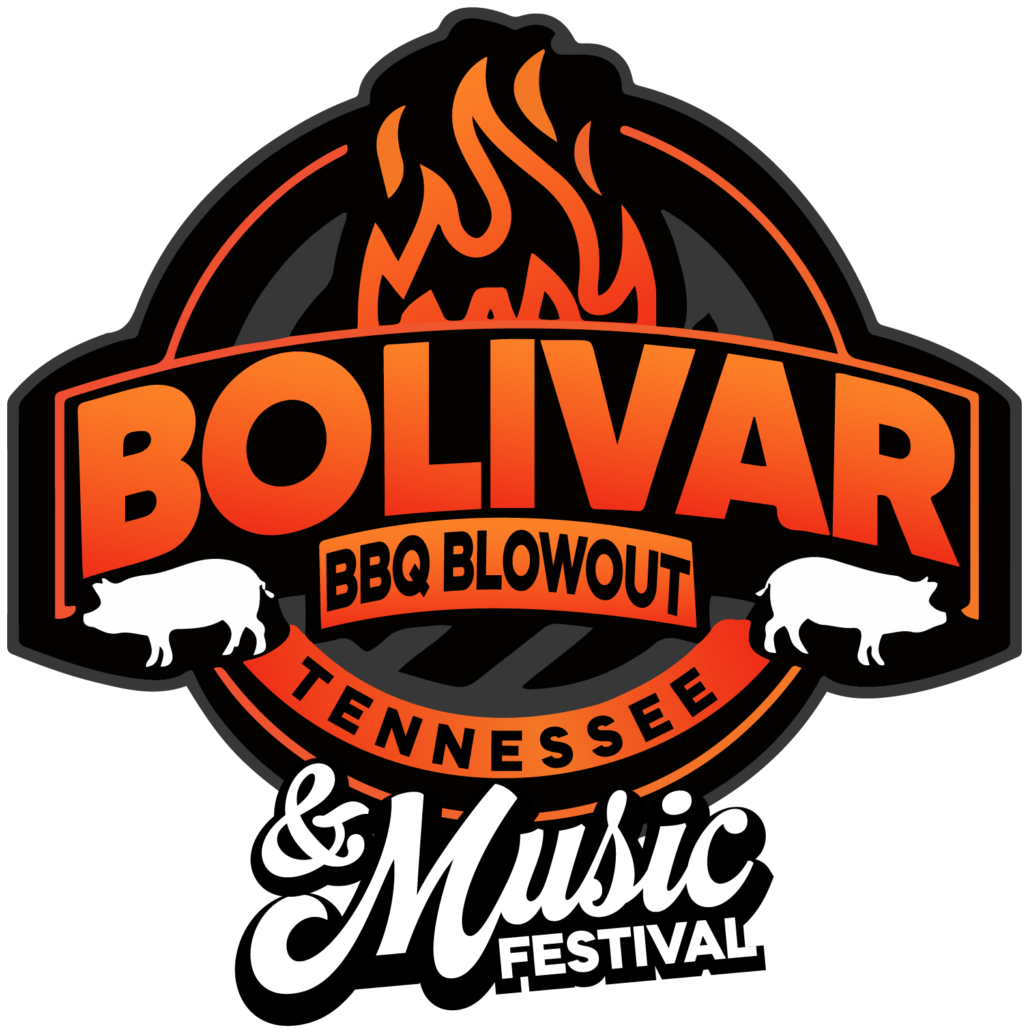
Team Application
Check ONLY one of the following: Pro Team Backyard Team
Official Team Name:

Chief Cook: Contact Person:

Mailing Address:

City: State: ZIP Code:

Phone: (day) Phone: (Evening)

Email:

Payment for the total entry fee must be received with application no later than October 16, 2026. Applications submitted are not guaranteed entrance. The Bolivar BBQ Blowout reserves the rights to reject any application after spaces are full. If your application is not accepted, your money will be refunded. However, no refunds will be made once you have been accepted into the contest. Limited space is available so apply early to secure your admittance. Any photos taken at the event become the property of The Bolivar BBQ Blowout and may be used for promotional purposes. For any additional information, contact Executive Director Suzanne Rhea, suzannerhea@aol.com, 731-609-1568.
I am entering this contest voluntarily and acknowledge that participation is a privilege, not a right. In exchange for the opportunity, we are limiting the team contestants to 25 - be sure to apply early. To participate in The Bolivar BBQ Blowout, I assume all risks and indemnify and release all sponsoring and/or hosting entities, including but not limited to the City of Bolivar, The Bolivar BBQ Blowout, the Memphis Barbecue Network, and their employees, agents and volunteers from any and all liability for personal injury arising out of my or my team’s participation in this event. Complete this form and return it along with your registration fee no later than Friday, October 16, 2026.
I agree to abide by all the rules and regulations of The Bolivar BBQ Blowout and the MBN and I understand that their decisions are final.
**A completed list of rules can be found at www.mbnbbq.com**
Cooks meeting FRIDAY, OCTOBER 23, 2026, at 5pm. * MANDATORY
Signature: ________________________________________________________ Date: ________________

PRO DIVISION GRAND CHAMPION PRIZE: $2500.00 + TROPHY
CATEGORY | 1ST PLACE | 2ND PLACE | 3RD PLACE | 4TH PLACE | 5TH PLACE
Whole Hog | $1,000.00 +Trophy | $800.00 +Trophy | $600.00 +Trophy | $500.00 + Trophy | $400.00+Trophy
Pull Pork | $1,000.00 +Trophy | $800.00 +Trophy | $600.00 +Trophy | $500.00 + Trophy | $400.00+Trophy
Ribs | $1,000.00 +Trophy | $800.00 +Trophy | $600.00 +Trophy | $500.00 + Trophy | $400.00+Trophy
BACKYARD DIVISION GRAND CHAMPION PRIZE: $1000.00 + TROPHY
CATEGORY | 1ST PRIZE | 2ND PRIZE | 3RD PLACE
Pull Pork | $600.00 + Trophy | $400.00 + Trophy | $300.00 + Trophy
Ribs | $600.00 + Trophy | $400.00 + Trophy | $300.00 + Trophy
Chicken | $600.00 + Trophy | $400.00 + Trophy | $300.00 + Trophy

CATEGORIES & FEES PRO DIVISION
CATEGORY | COST PER ENTRY | CHECK CATEGORIES |  | AMOUNT DUE
Whole Hog | $125 |  | $
Pull Pork | $125 |  | $
Ribs | $125 |  | $
MBN Team Fee* | $15 | N/A | $ | 15.00
$125 for first category entry and $100 for each additional category
BACKYARD DIVISION
CATEGORY | COST PER ENTRY | CHECK CATEGORIES |  | AMOUNT DUE
Pull Pork | $100 |  | $
Ribs | $100 |  | $
Chicken | $100 |  | $
MBN Team Fee* | $15 | N/A | $ | $15.00
$100 for first category entry and $75 for each additional category
*Electricity included in entry fees (20 amps).
*MBN Team Fee must be included in your total entry fee.
Porta-a-john @ $137.00 Each
ENCLOSED TOTAL ENTRY FEES: $ ____________________

METHOD OF PAYMENT
Check (Please make checks payable to Bolivar BBQ Blowout)
Credit Card (Visa, MasterCard, American Express)
Cash
CREDIT CARD INFORMATION (IF APPLICABLE)
Cardholder Name: Card Number:

Expiration Date: CVV:

Signature: Date:

Please return this form along with payment to:
THE BOLIVAR BBQ BLOWOUT c/o SUZANNE RHEA
211 North Washington
BOLIVAR, TN 38008
or copy and send by email to: suzannerhea@aol.com
*For information about amps contact: SUZANNE RHEA @ 731.609.1568
I understand that I am responsible for my team’s conduct. We agree to behave in a courteous and professional manner that upholds the spirit of barbecue. I understand that failure to comply with this rule may mean ejection from the contest or disqualification. I understand that QUIET TIME starts at midnight Friday. I will turn my music DOWN.

Signature of Head Cook Date

**Online applications available on our website at www.cityofbolivar.com/bolivarbbqblowout.

